Task 5 : Develop Laundry Mart login Page using flex

Develop a user interface for a login page that aims to provide a visually appealing and user-friendly experience to individuals attempting to log in to a system.

[Link01](https://www.youtube.com/watch?v=B8BFVzbKmPI)

**Development Description** : A simple login page with a split layout. On one side, there is an illustration, and on the other side, there is a form for users to input their **email and password for logging in**. The goal is to create an engaging design that encourages users to interact with the login process.

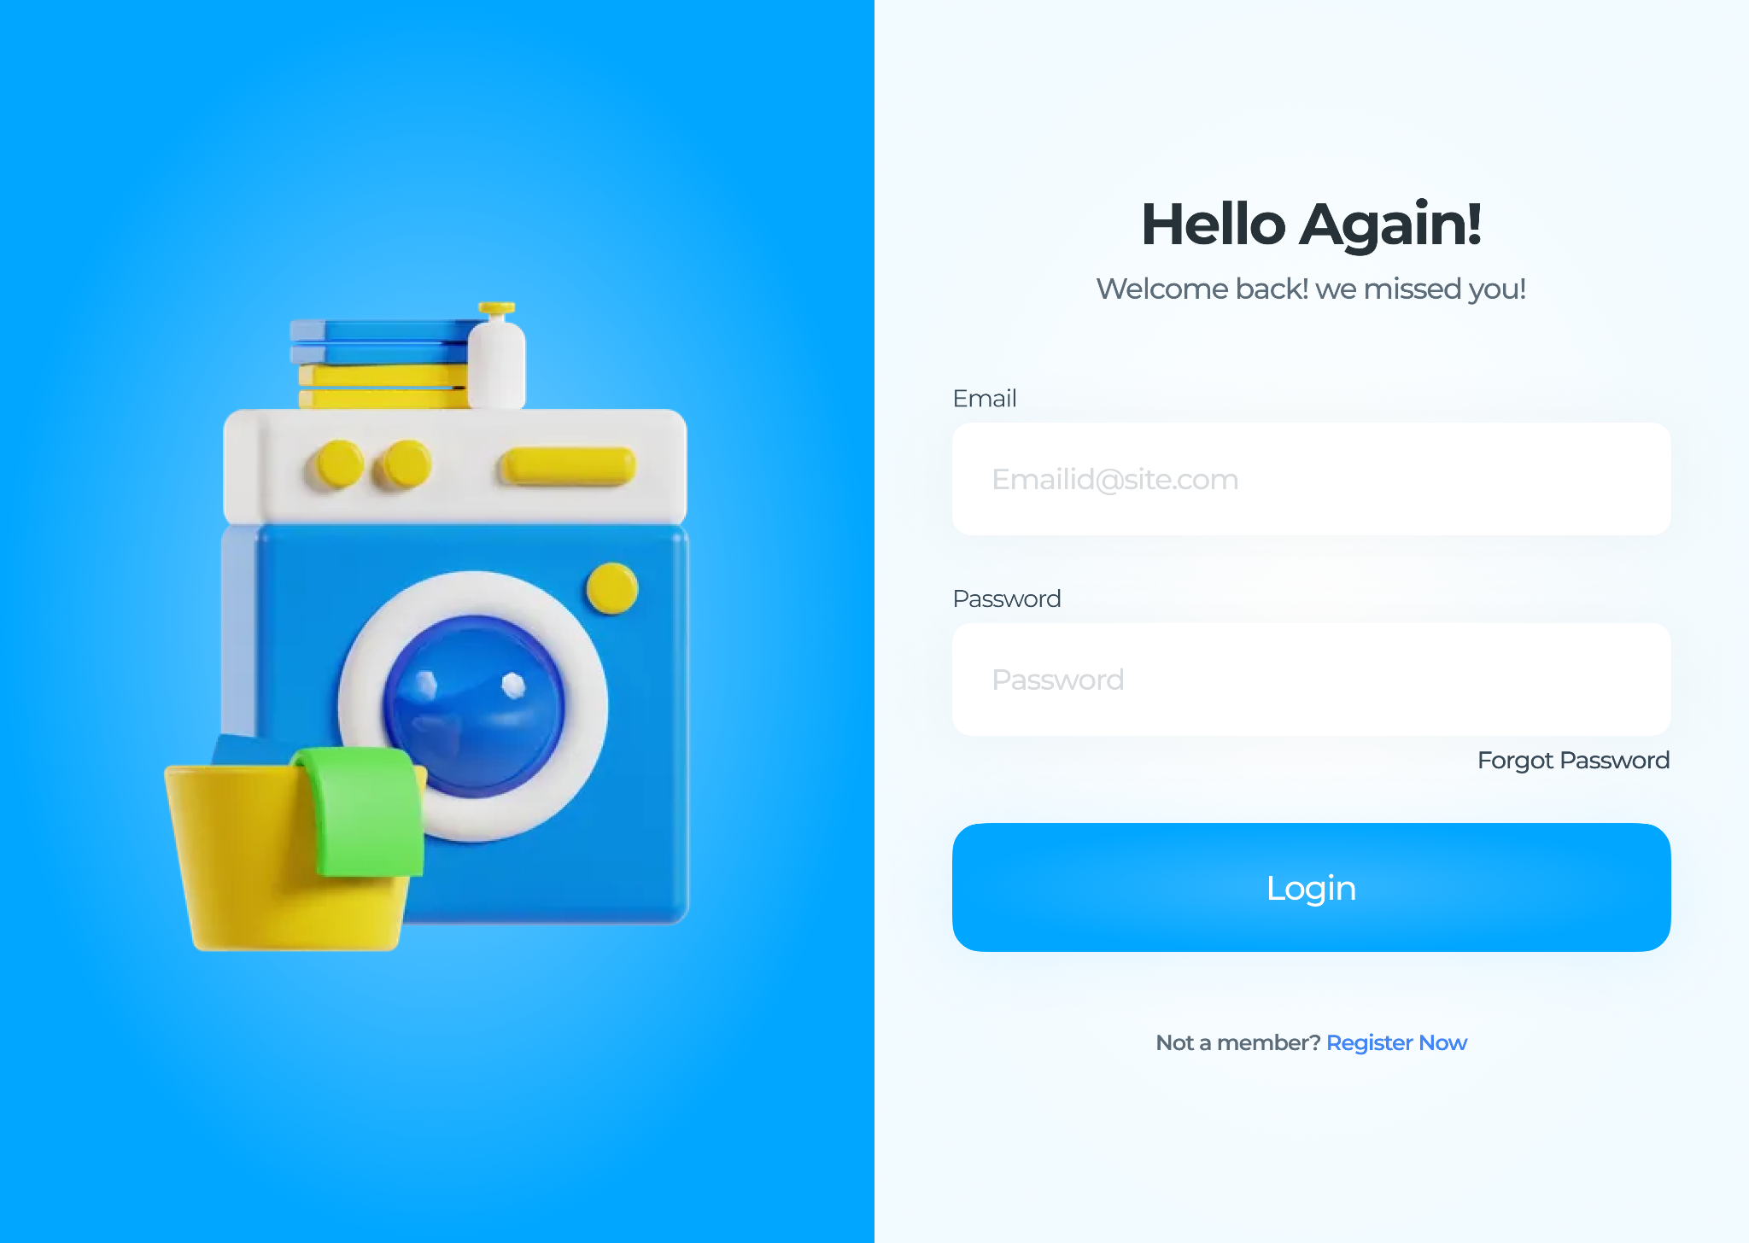

**Web page breakdown :**

1. Container Setup:

* Create an HTML file with the necessary tags.
* Ensure the content is **centred** on the page.
* Container height should be 100vh.

2. Left Section:

* Add an image on the left side centre.(You can use any image from the internet).

3. Form Section:

* Set up a section for the login form inside the container.
* Add padding and use **flexbox** for a neat layout.

4. Form Heading and Description:

* Include a heading element for a friendly greeting.

5. Email and Password Inputs:

* Place input fields for email and password.
* Specify the type and add **placeholder** text for guidance.
* Style the inputs to look clean and organised.

6. Login Button:

* Add a button element labelled **"Login".**
* Style the button to make it stand out and look appealing.

By completing these tasks, the goal is to Learn Basic CSS properties. We will keep learning more css properties in further assignments. ( Don't use margin padding to make it in the centre. Use FlexBox.)

**Submission : (Submission Link)**

**Submission instructions and guidelines.**

* Deploy your project on Netlify and submit the deployed link in the given submission form.
* Again the page should be properly structured. It should not go in scroll.
* Don't Use bootstrap, Implement only using CSS
* Netlify Project Deployment Link : (Add here)
* Submission Link : [https://upskillmafia.com/mern/dashboard/tasks](http://upskillmafia.com/mern/dashboard/tasks)
* If you dont know how to deploy watch this:- <https://youtu.be/Ii2Y4i4_i-o>

|  |
| --- |
| **Note :** You can take help from **Internet** or You can also connect with upskill Mafia **Mentors** |